Mushroom Classifier

***Wireframe Documentation***

**Home page**

1. This home page that should be available for the user.

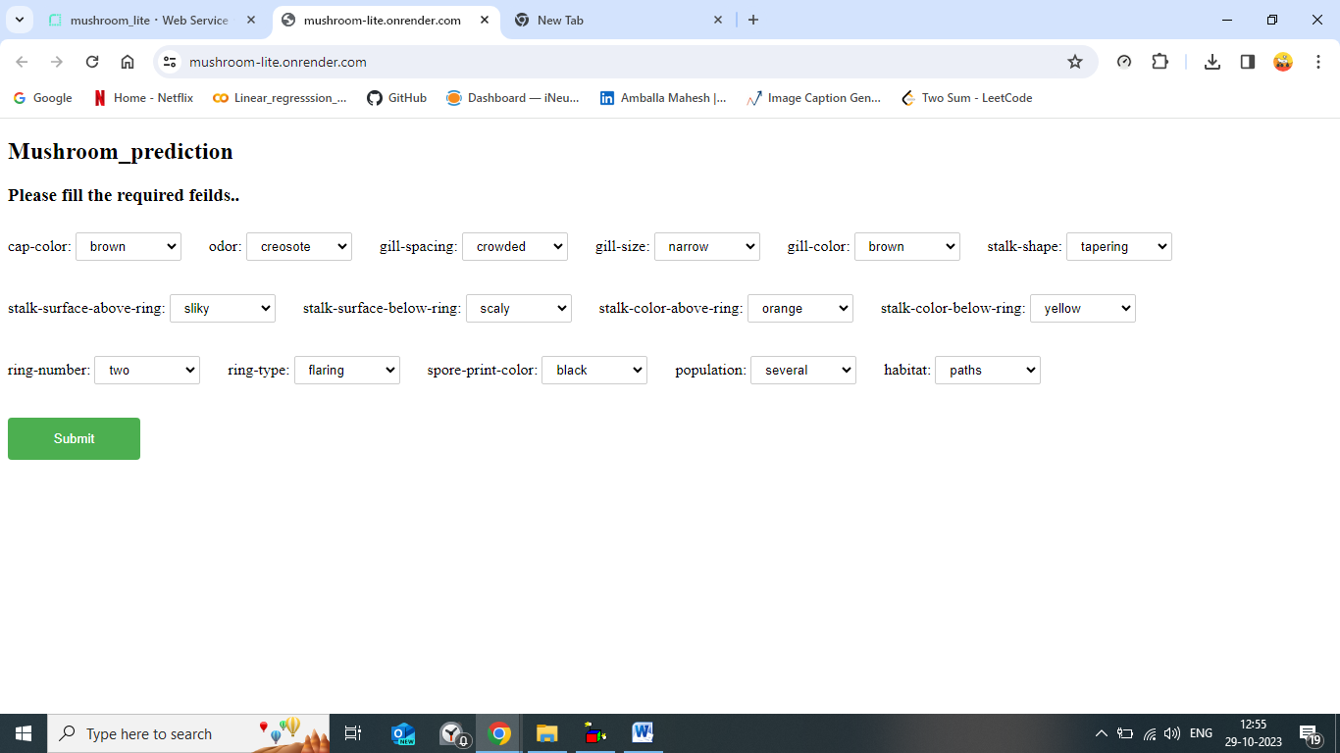

1. The user should get the output as below mentioned..

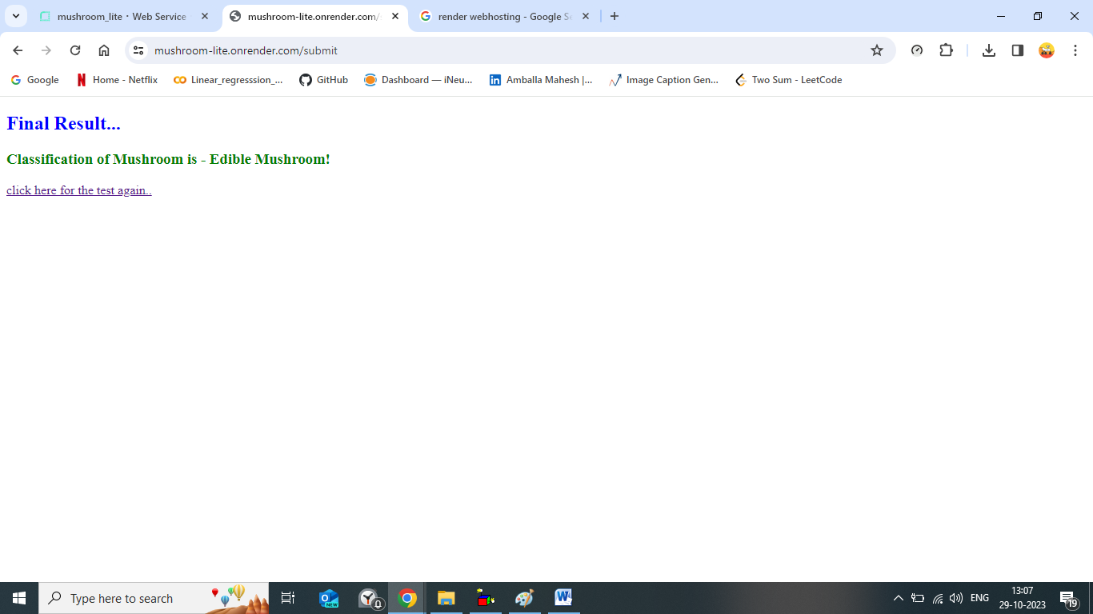

1. Once click the ***click here for test again*** the home page should load again.



1. Check the logging file whether the logging is active or not.

